**COMP 3710 Artificial Intelligence**

Fall 2013

Term test II

Student Name: Student Number:

1. (2 marks) Prove ~(~*p* ∧ *q*) ∧ (*p* ∨ *q*) = *p* by using equivalence, not the truth table.
2. (3 marks) Convert *A* ↔ (*B* ∨ *C*) to a CNF.
3. (2 marks) List the two major reasons why rule-based expert systems have not been successful.
4. (2 marks) Convert the following rules to Horn clauses.

Rule 1. IF *A* and *B* THEN *C*

Rule 2. IF *A* THEN *D*

Rule 3. IF *C* and *D* THEN *E*

Rule 4. IF *A* and *E* THEN *H*

Rule 5. IF *D* and *E* and *H* THEN *I*

1. (3 marks) With the rules in the previous question and the facts *A*, *B*, *F*, do backward chaining to prove the hypothesis *I*. You need to show step-by-step how the backward chaining works.
2. Consider the inverted pendulum problem.
   1. (2 marks) The input for *Theta* is NS:0.6 and ZE:0.3, and the input for *dTheta* is NS:0.4 and ZE:0.5. Find the output fuzzy sets with membership values, using the next fuzzy rules. (Note that the numbers after fuzzy sets are membership values.)

|  |  |  |  |  |  |
| --- | --- | --- | --- | --- | --- |
|  | *Theta* | | | | |
| *dTheta* |  | NM | NS | ZE | PS |
| NM |  |  | PM |  |
| NS |  |  | PS | ZE |
| ZE | PM | PS | ZE | NS |
| PS |  | ZE | NS |  |
| PM |  |  | NM |  |

* 1. (3 marks) Defuzzify the output fuzzy sets obtained in (a), using the centroid method with the next fuzzy membership functions.

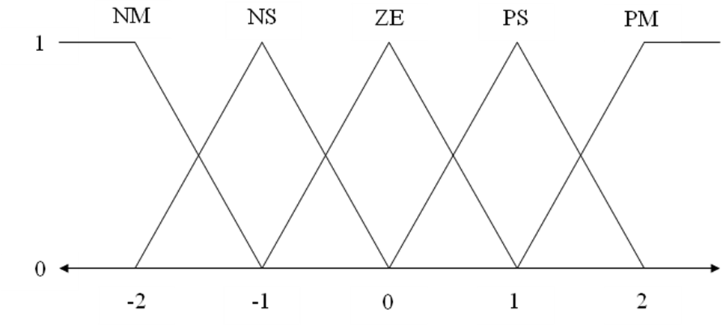

1. (3 marks) Compute the information gain for *Genre*. You do not have to compute the logarithms. (Here are the related formulas.

Information Gain = 1 - ∑ (the weighted entropies)

Entropy = – p0 × (log2 p0) – p1 × (log2 p1) – ...

|  |  |  |  |  |
| --- | --- | --- | --- | --- |
| **Film** | ***Country*** | ***Big Star*** | ***Genre*** | **Success** |
| Film 1 | *USA* | *Yes* | *SF* | True |
| Film 2 | *USA* | *No* | *Comedy* | False |
| Film 3 | *USA* | *Yes* | *Comedy* | True |
| Film 4 | *Europe* | *No* | *Comedy* | True |
| Film 5 | *Europe* | *Yes* | *SF* | False |
| Film 6 | *Europe* | *Yes* | *Romance* | False |
| Film 7 | *Other* | *Yes* | *Comedy* | False |
| Film 8 | *Other* | *No* | *SF* | False |
| Film 9 | *Europe* | *Yes* | *Comedy* | True |
| Film 10 | *USA* | *Yes* | *Comedy* | True |

1. (3 marks) Here is a training data set. Classify (2, 4) by using the 2-nearest neighbor algorithm.

|  |  |  |
| --- | --- | --- |
| *X* | *Y* | *Class* |
| 1 | 1 | *Blue* |
| 1 | 2 | *Blue* |
| 2 | 1 | *Blue* |
| 2 | 2 | *Green* |
| 2 | 3 | *Green* |
| 3 | 1 | *Green* |
| 3 | 2 | *Green* |
| 4 | 1 | *Green* |
| 3 | 3 | *Red* |
| 4 | 2 | *Red* |
| 4 | 3 | *Red* |